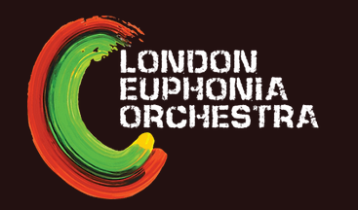
LEO Christmas Concert
Date: Saturday 3rd December
Venue: St Paul’s Church, Knightsbridge

Rehearsals (all Tuesdays)
Every section will be rehearsing each week, so please put as many of these dates in your diary as possible!
Date | Venue | Full or sectional
11 October | St Joseph’s Hall | Full
18 October | St Mary Aldermary | Full
25 October | St Joseph’s Hall & Moorgate Crypt Hall | Sectionals
1 November | St Mary Aldermary | Full
8 November | St Joseph’s Hall | Full
15 November | St Mary Aldermary & Moorgate Crypt Hall | Sectionals
22 November | St Joseph’s Hall | Full
29 November | St Joseph’s Hall | Full

Programme
Dependent on the musicians who sign up, we have two options. The first option will be for a large orchestra including lots of brass. The second option will be for a smaller orchestra.
Option 1:
Humperdinck – Hansel Und Gretel
Tchaikovsky – Romeo and Juliet Fantasy Overture
Tchaikovsky – Nutcracker Suite

Option 2:
Beethoven – Coriolan Overture
Mozart – selection of favourite arias
Beethoven – Symphony 1

How to sign up:
Please use the link in the email you were sent today. Make sure you put the dates in your diary!!

